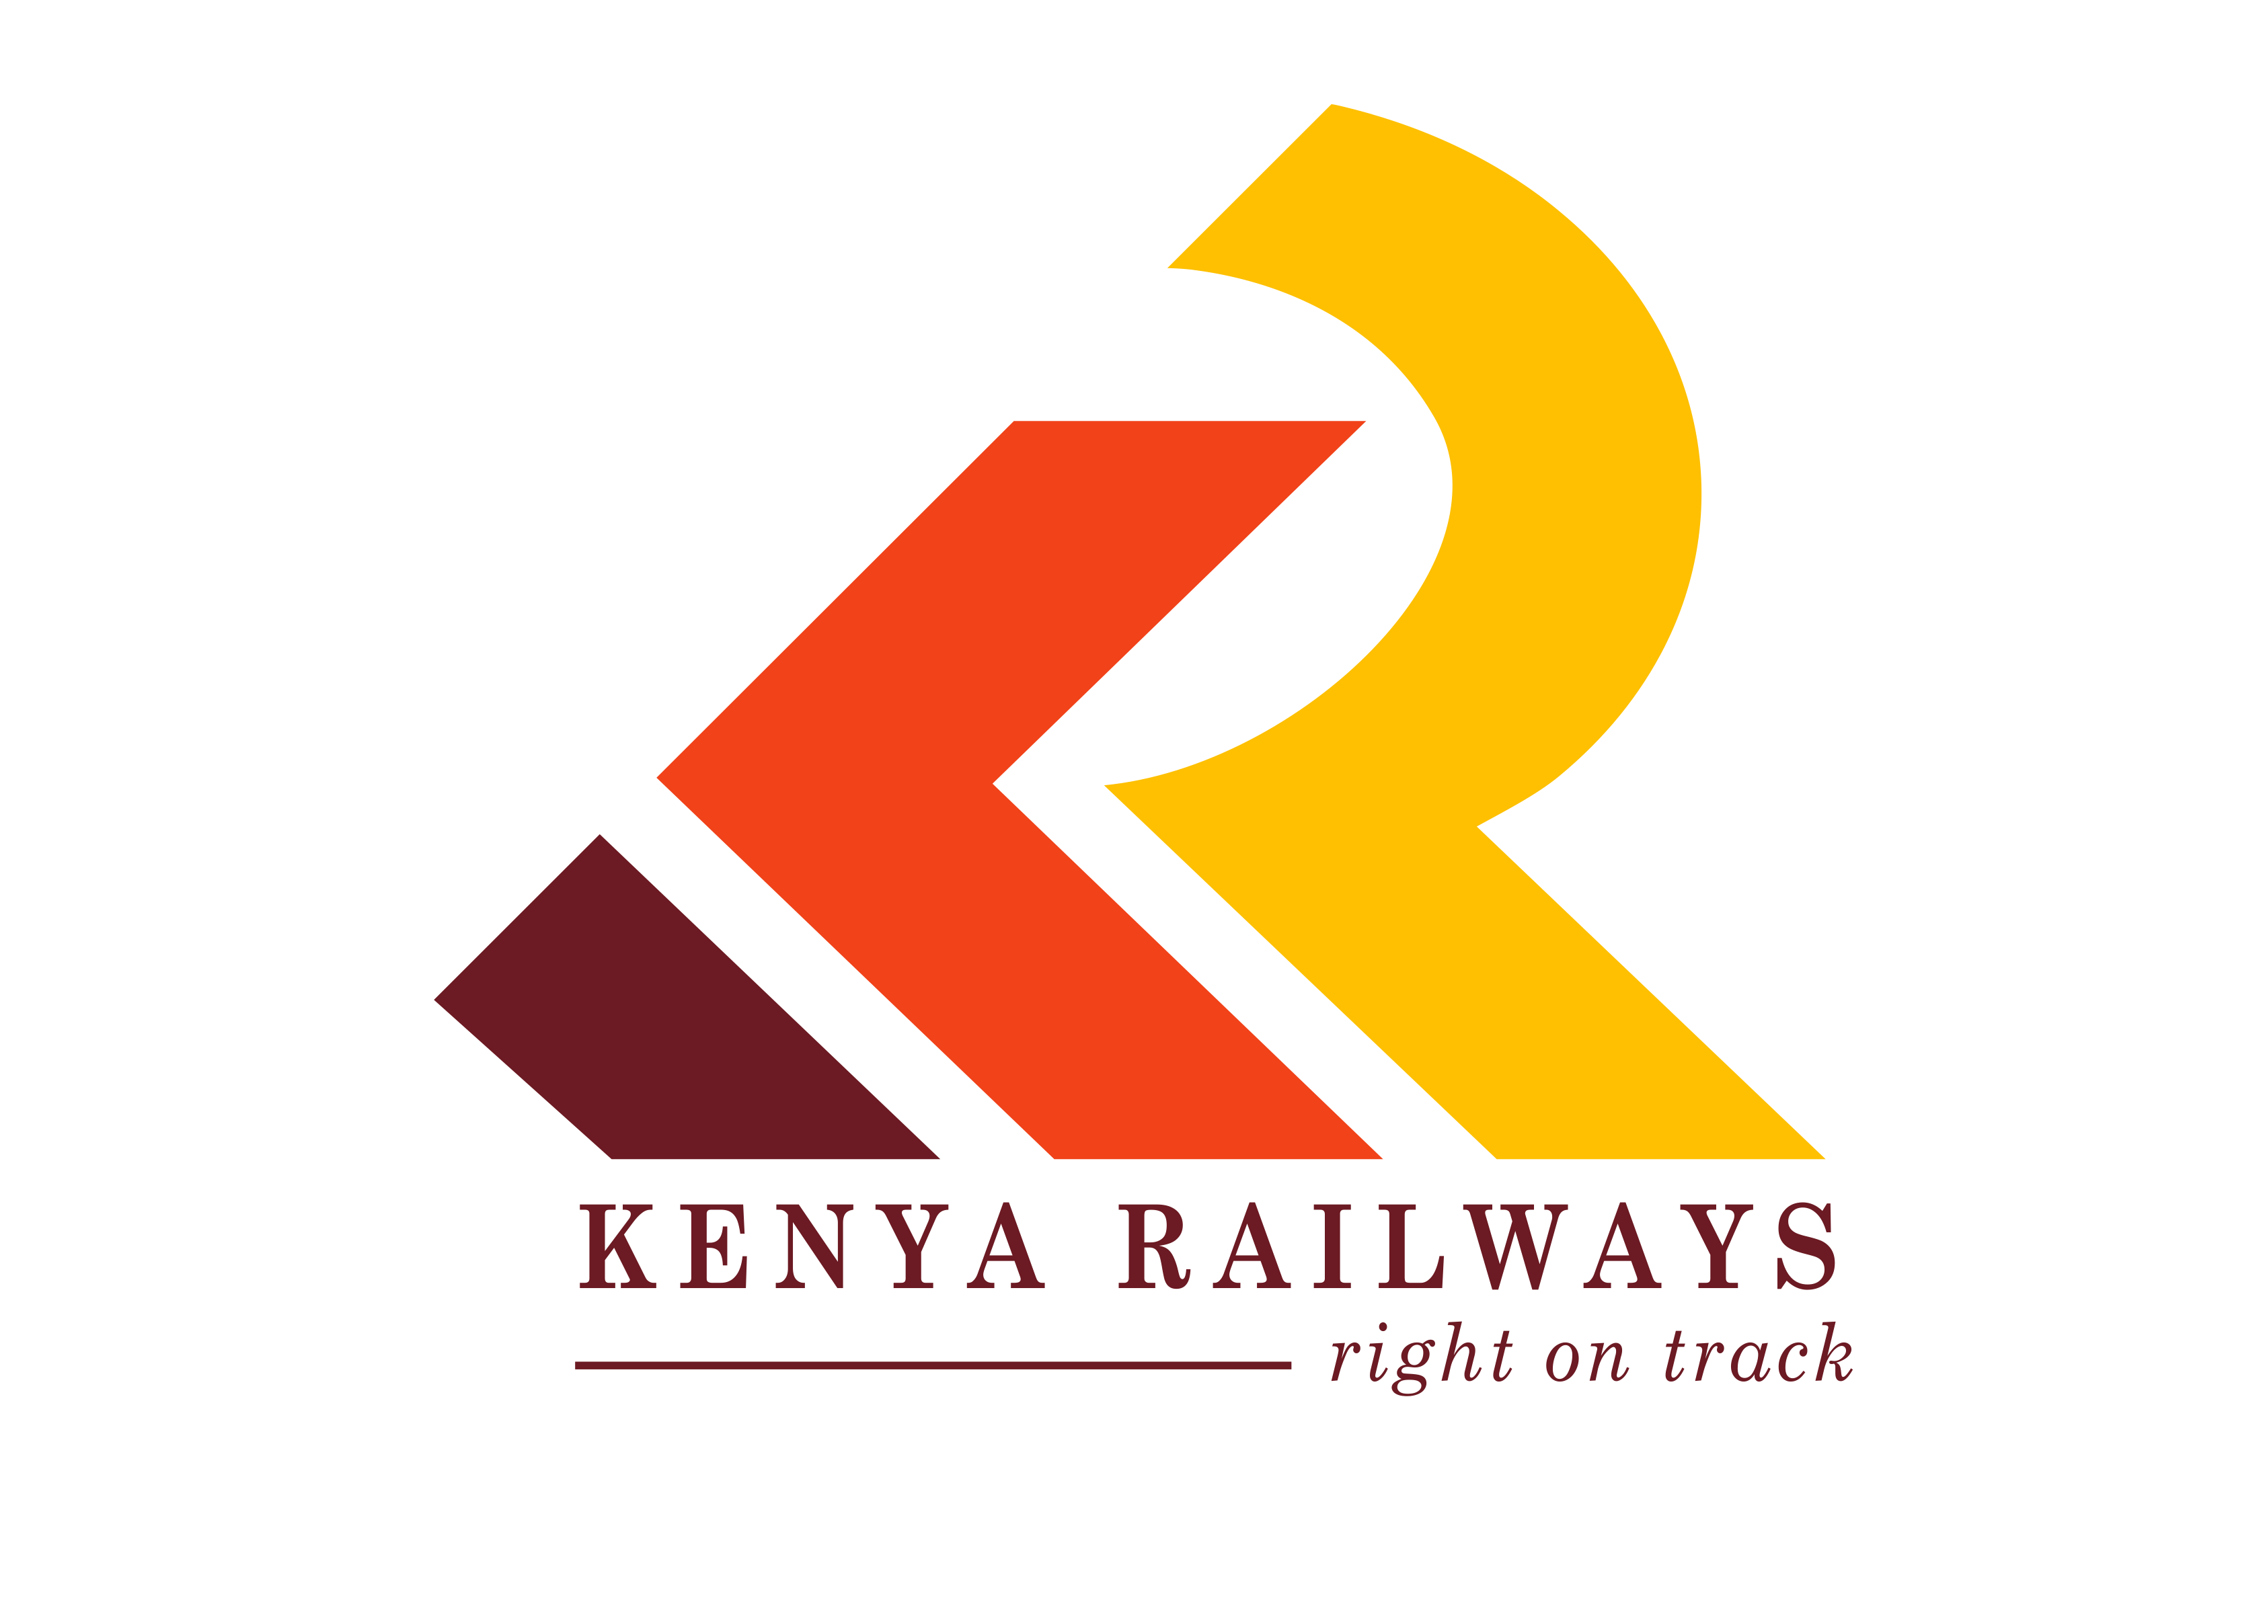

REPORT TITLE: CREW AND FUEL MANAGEMENT

PERIOD OF TRAINING: Quarter 2

PREPARED BY: Emmanuel Kahindi Karinda

REF: CNT/ 00558

DATE: Sept, 2022



Table of Contents
1
EXECUTIVE SUMMARY 4
INTRODUCTION 4
Railway Crew Management 4
Crew booking criteria 7
Driver Trip analysis 7
CREW PERFORMANCE 9
Driver’s Performance 9
LIO’s performance 11
Challenges in trip Anaysis 12
FUEL MANAGEMENT 13
Fuel consumption 13
Fueling stations 14
Conditions for fueling 14
Fueling procedure 14
Fuel System Update 14
Monthly Fuel Tallies 15
Challenges in Fuel management 15
CONCLUSION 16
RECOMMENDATIONS 16

List of Tables

Table 1 Total crew breakdown 6
Table 2 Commuter and DMU drivers 6
Table 3 Eastern Driver performance 9
Table 4 Central Driver performance 10
Table 5 Western driver’s performance 10
Table 6 LIO performance 11
Table 7 Region performance trip download 12
Table 8 Loco full capacity 13
Table 9 Monthly fuel tallies 15

EXECUTIVE SUMMARY
This report mainly focused on the crew and fuel management of the MGR, analysis of the train trips done by drivers as well as LIO’s performance on trip downloads availability.

INTRODUCTION

Railway Crew Management
Railway crew management is the process of guaranteeing in the most effective way that the timetabled trains are supplied with a train driver and a sufficient number of train guards, thereby satisfying all the relevant practical constraints.
Crew management has long term capacity planning aspects as well as short term scheduling, rostering, and dispatching aspects.
The crew management structure in Kenya Railways is as follows;

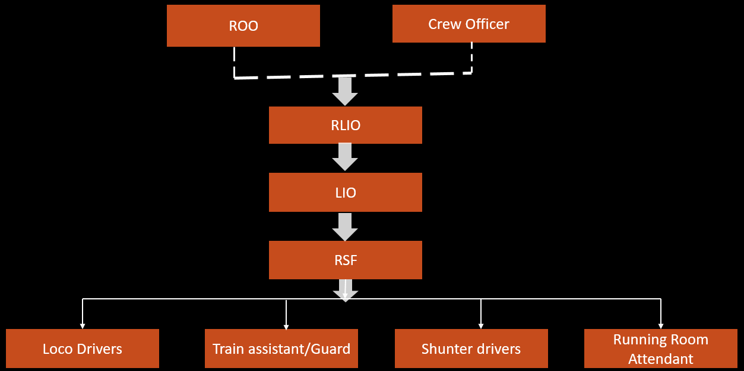
Figure 1 MGR crew structure

- Regional Operation Officer- The ROO is in charge of the region.
- Crew Officer- Stationed at the Headquarters whose work is to analyse the whole train, in terms of fuel consumption, stoppages, safety of the drivers.
- Regional Locomotive Inspectors Officer- In charge of the crew.
- Locomotive Inspectors Officer- LIO ensures the assessment of how the crew handles the train. Check their performance, have briefs with the crew to ensure they have maximum ability.
- Running Shift Foreman- The RSF manages shift days, off days of the entire crew. They also assess the condition of the driver.
- Locomotive drivers- They are responsible for driving the locomotives. They are categorized into senior locomotive drivers and locomotive drivers.
- Train assistant/ Guards- They accompany the driver in the locomotive.
- Senor shunter driver
- Shunter driver
- Running room attendant- They ensure the running room is clean and well maintained.
For some special freight trains, they have Locomotive driver, guard and a police escort.
The running rooms are points where crew change is done. The stations with running rooms in Kenya railways MGR are
- Mtitu Andei
- Nakuru
- Malaba.
The Kisumu and Nanyuki running rooms are to be introduced.

Breakdown of the total crew in different regions for MGR
 | Eastern | Central  MKR SGA |  | Western  ELD MLB KSM
Locomotive Inspector officers | 2 | 5 |  | 2
Running shift officer | 3 | 4 |  | 2
Locomotive Drivers | 19 | 40 | 3 | 21 |  | 2
Train Guards | 6 | 16 | 2 | 5 |  | 2
Senior Shunters | 10 | 15
Shunters |  | 7 | 1 | 5
Running room attendants | 5 |  |  |  | 3
Table 1 Total crew breakdown
Commuter and DMU drivers
Central
Nanyuki | Commuter | DMU
Mainline 3 | NRB- 20  SGA- 3 Passenger train drivers | NRB- 11
Train Assistant 2
Shunter 1
Table 2 Commuter and DMU drivers
Western
Kisumu passenger train drivers are 2 and Eldoret 3.

Crew booking criteria
Before the RSF books any train to a driver, he has to consider several factors which include;
- Locos that a driver is certified to operate- The driver should have locomotive knowledge, know how the entire air brake system functions, know the Operating rules and procedures which includes the ROR and be familiar with the route.
- Crew ranking
- Shunter driver- performs shunting at the yard only
- Group 1 mainline drivers- These are the senior mainline drivers operating trains over long mainline distances. Example from MTO-NRB
- Group 2 mainline drivers- They are junior mainline drivers operating trains over short mainline distances Example TKA, ATR, RIU
- Leave (Annual leave, sick off, trip off)
- Rest (10 hours home depot, 8 hours away depot)
- Special trains e.g. D-trains which only EPRA certified drivers can operate

Driver Trip analysis
A trip analysis is done once the driver has reached the destination. The driver inserts a pen drive to the OBC which records the whole train movement. The pen drive is then inserted to a computer with APDT software so that the data can be downloaded to the system. APVis software is then used to analyze downloads.

Parameters of the Download
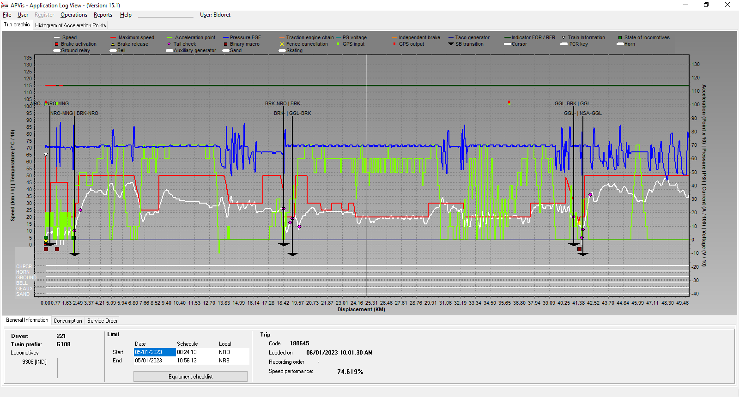
Figure 2 APVis parameters
- The green and red line on top shows the direction of travel. The green line is forward motion while red is reverse.
- The blue line indicates the train pipe pressure.
- The red line indicates the speed restriction.
- The white line shows the train speed
- The light green line indicates the throttle/acceleration of the train
- The purple circles are tail conferences which are macro 5 sent by the driver to share their position while entering and leaving a station.
- The red squares are penalties which appear when drivers over speeds.

Other software used for analyzing the trip downloads include;
Trip Analyzer- An excel with formulas that tabulates the train handling adherence.
Px Chart- Used for planning the movement of trains and crossings.

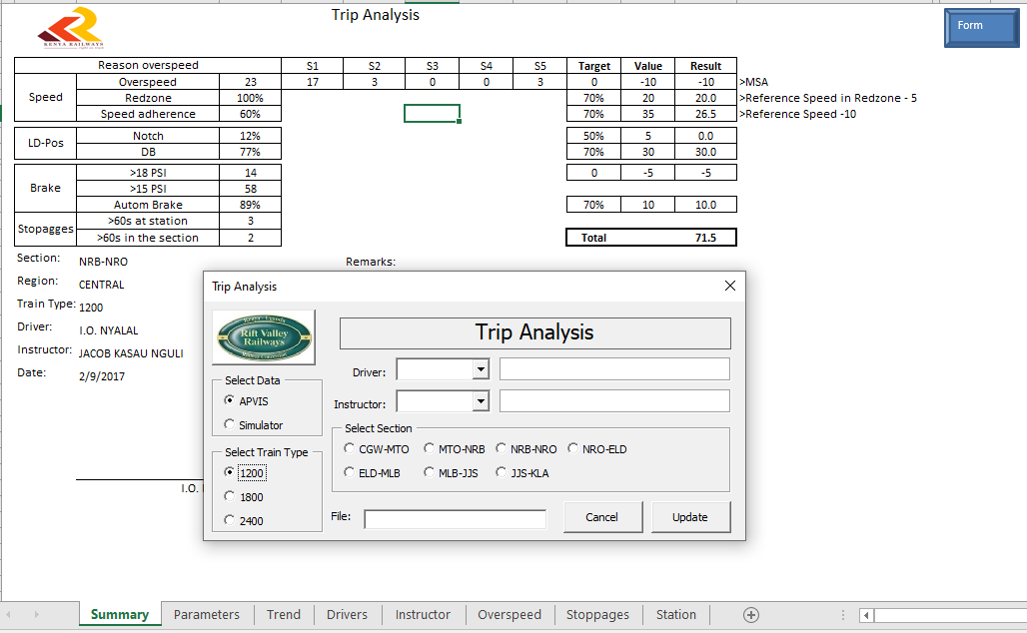
Figure 3 Trip analyzer parameters

CREW PERFORMANCE

Driver’s Performance
Analysis of the train handling performance by drivers on each region while considering the set KPI’s by the organization.
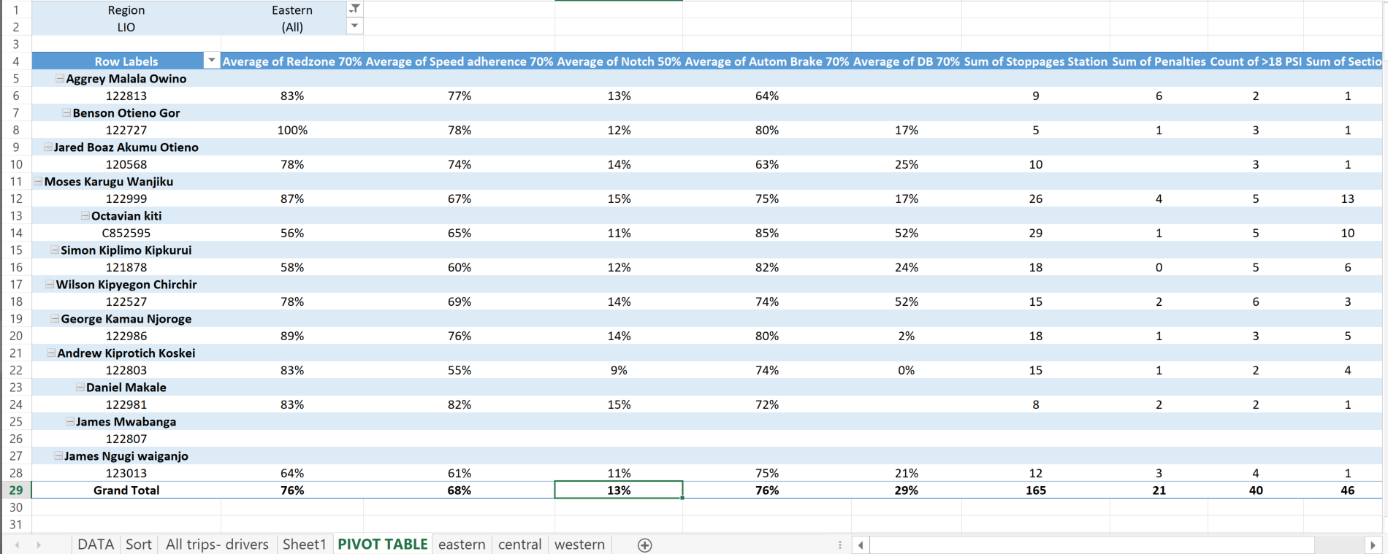
Table 3 Eastern Driver performance
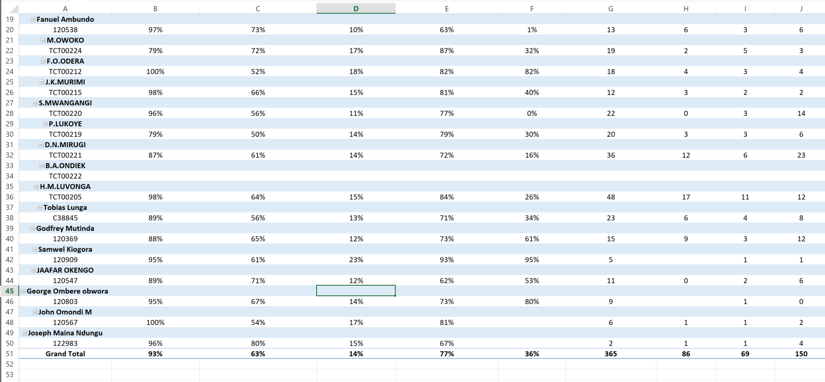
Table 4 Central Driver performance
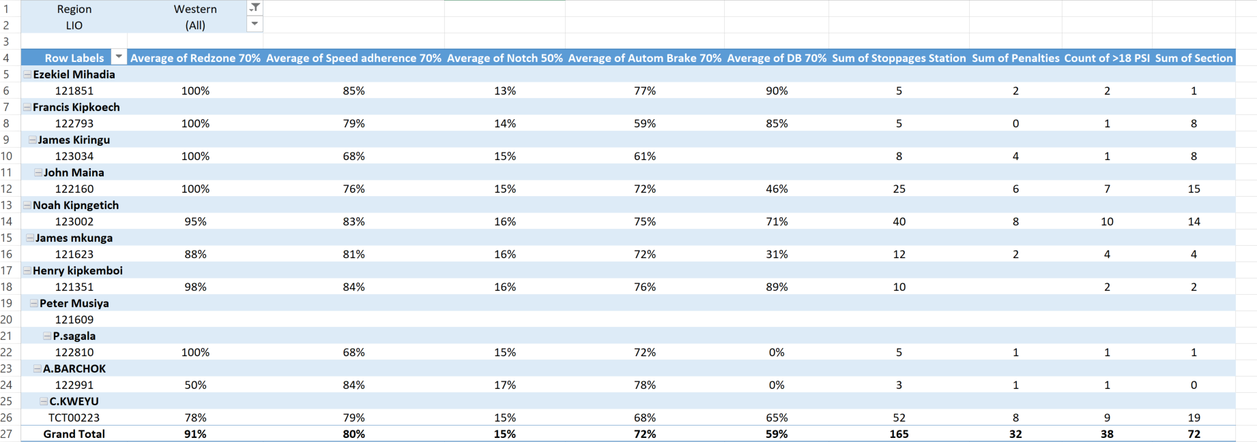
Table 5 Western driver’s performance
From the above three tables, it can noted that western region drivers have better train handling having met most of the pass scores for the set KPI’s. The notching performance is below target because of the poor state of the track, where drivers move with lower notches which also increases the loco fuel consumption. Dynamic brake is also low because some locos like 96XX have issue with DB

LIO’s performance
Each LIO is assigned a number of drivers whom they have to monitor their performance in terms of train handling and trip downloads. Below is each LIO and the number of drivers each have.
LIO Drivers
James Mwabanga 15 Philemon Sagala 14
Rodgers Mwangoma 17 Pius Makokha 17
Edgar Mbui 20
Jaafar Okengo 12
Wlliam mwathi 17
Godfrey mwanga 13
Downloads are analyzed into an excel format to show which LIOs and regions are efficient in ensuring all trip downloads are available for analysis.
LIO | January | February | March | April | May | June | July | Total Average
Rodgers Mwangoma | 60% | 89% | 63% | 77% | 69% | 80% | 94% | 76%
James Mwabanga | 71% | 86% | 43% | 86% | 68% | 88% | 79% | 74%
Jaafar Okengo | 34% | 35% | 21% | 46% | 32% | 79% | 48% | 42%
William Mwathi | 43% | 56% | 34% | 78% | 48% | 70% | 65% | 56%
Edgar Mbui | 56% | 50% | 39% | 54% | 75% | 70% | 77% | 60%
Godfrey Mwanga | 50% | 83% | 33% | 33% | 60% | 58% | 58% | 54%
Philemon Sagala | 61% | 70% | 16% | 55% | 36% | 63% | 71% | 53%
Pius Makokha | 47% | 78% | 31% | 49% | 49% | 60% | 79% | 56%
Table 6 LIO performance

Table 7 Region performance trip download
From the above two tables, table 6 and 7, Rodgers Mwangoma has overall better performance in ensuring all trip downloads are available for analysis. Eastern region as a whole has better performance compared to the other regions for trip downloads.

Challenges in trip Anaysis
- Missing trips due to delay in uploads.
- Faulty OBC ports causing invalid trip downloads
- Lack of electricity on several stations like Eldoret and Mtitu making it impossible to upload trips
- Backdating APVis in order to search missing trips.
- Delayed updating of APVis making recent trips unavailable
- Network issues affecting the functionality of APDT
- PX Chart not working for the past 2 months

CONCLUSION

With railway providing a safer way to move large quantities of cargo from one point to another due to less accidents and pilferage, it is expected that more people would prefer to use it. A proper crew management system would ensure this is met as all the planning would be achieved with crew availability.

RECOMMENDATIONS

- Provision of clear and well defined succession plan for crews in order to curb the issue of lack of enough crew.
- Urgency in handling crews with incidents cases in order to minimize cases of crew shortages due to indiscipline
- Having more LIO’s especially in Central region for easier assessments of drivers performance in train handlings.
- Certifying more drivers who can handle the special trains like D trains.
- Providing refresher course for those drivers with train handling challenges. E.g line testing.
- Rehabilitation of the track to improve on train handling such as notching.
- Provision of better facilities and equipment such as computers, sockets at the RSF and LIO’s offices.
- Improving crew working environment such as changing rooms, state of locomotives.
- Reintroducing the simulator to help in teaching train handling skills and safety while reducing maintenance and fuel consumption.
Report prepared by; Emmanuel Kahindi Karinda

Supervised and checked by;

Approved by;

